¿Qué hora es?

___________________________________________ / ___________________________________________

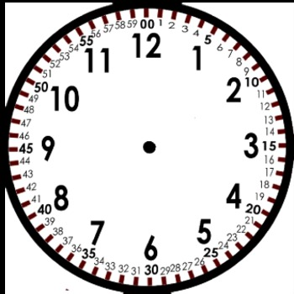

- Listen to the times your teacher calls out. Then, write the times you hear in the spaces provided.
:
:
:
:
:
:
:
:
:
:

ESTUDIANTE A

- Now, listen as your partner reads off the times that are printed on his paper. Write the times on your own paper. Then, switch roles.

10
10
1
26
9
45
5
18
:
:
:
:
:
:
:
:

A. Time Hangman
Circle 3 times for your first game from the first list. HIDE THIS FROM YOUR PARTNER! Your partner will have 6 chances to guess the time you have secretly selected. Mark on the hangman in order to keep track. Once your partner guesses the secret times, or runs out of chances, the first game is over. Then, your partner will select 3 times of their own and you will guess the time.

First game:
1:10 1:05 3:12 3:25 5:22 5:20 7:15 7:05 9:20 9:15 11:05 11:17

Second game:
1:30 1:40 2:15 2:45 4:30 4:35 6:45 6:40 8:50 8:45 10:30 12:55

Third game:
1:13 1:15 3:22 3:30 5:55 5:25 8:10 8:50 10:05 10:20 12:40 12:33

ESTUDIANTE B

- Now, listen as your partner reads off the times that are printed on his paper. Write the times on your own paper. Then, switch roles.

12
15
8
20
7
50
3
33
:
:
:
:
:
:
:
:

B. Time Hangman
Your partner has selected 3 secret times from the first list. Try to guess the times they selected. They will mark on the hangman if you get it wrong in order to keep track. You will have 6 chances. Once you guess the secret times, or run out of chances, the first game is over. Then you circle 3 times and your partner will try to guess. HIDE THIS FROM YOUR PARTNER!

First game:
1:10 1:05 3:12 3:25 5:22 5:20 7:15 7:05 9:20 9:15 11:05 11:17

Second game:
1:30 1:40 2:15 2:45 4:30 4:35 6:45 6:40 8:50 8:45 10:30 12:55

Third game:
1:13 1:15 3:22 3:30 5:55 5:25 8:10 8:50 10:05 10:20 12:40 12:33

