For the next section, you search through Capítulo 1A, the chapter that we are working on (p. 25-47).
12. According to the chapter, name four activities (en español) that teenagers like to do in Latin America.
(a) (b) (c) (d)

13. What is one specific place the book mentions where teenagers in Latin America like spend time with their friends? _____________________

14. Who is Pablo Picasso? ________________Where is he from? ______________What style of art is he most famous for?_________________________ What is the name of one of his paintings?______________

15. Where did the Arabic Moors come from to invade Spain? ______________How long did they rule the country? ______What year were they defeated? (“famous year that someone sailed the ocean blue”)_______

16. What are the five languages spoken in Spain?
(a) (b) (c) (d) (e)
17. In what year will the Hispanic population in the U.S. reach 25% of the total population? __________

18. What two countries does España border? _____________________ and ________________

19. What are the names of four instruments (en español) that are used in Caribbean music?
(a) (b) (c) (d)

20. What countries are the following dances from?
el tango: el flamenco: el merengue:
la cumbia: la salsa:

21. In some countries, they say “no me gusta nada”, but in other countries they say _____________________________________ to mean the same thing.

22. With what word does English infinitive form begin? _________ How many infinitive forms are there in Spanish? _____ What are the endings of the infinitive form in Spanish? (a) (b) (c)

23. What country is Jaime Antonio González Colson from?_______________ What is the güiro made from?___________ How do you play it?_________________________________________________

24. There is a student named Pablo whose picture and likes and dislikes are featured in your book. What country is Pablo from? __________________ What continent is this country found on?___________ Did you know they speak Spanish there? _______ (Yes or no is okay to answer this question! )

25. Where did the dance called “el mambo” originate? ____________ In what year?___________

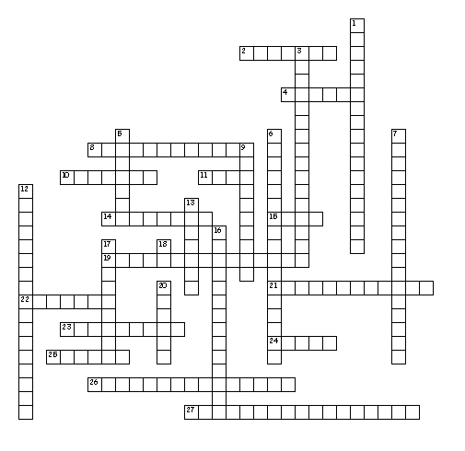

Horizontales
2. to draw
4. to dance
8. to go to school
10. to ski
11. and you?
14. to work
15. well
19. to write stories
21. to read magazines
22. I like to
23. I don't like to...
24. to swim
25. to run
26. to play the guitar
27. to play sports

Verticales
1. to ride a bicycle
3. to play videogames
5. to skate
6. to talk on the phone
7. to use the computer
9. I do too.
12. to skateboard
13. also
16. to listen to music
17. to watch television
18. yes
20. to sing

